Name: ___________________________________ Date: ________________ Period: _________

COURSE SYLLABUS AND CLASS CONTRACT
BIOLOGY
2019-2020

Teacher: Mrs. Katie Hawkins
Location: Room F-148
Phone: (931) 553-2070 Ext. 2648
E-mail: katherine.hawkins@cmcss.net
Website: katiehawkinsrhs.weebly.com

Google Classroom Code: ________________________

Remind Code: ________________________

- Biology is a course required for graduation and is a pre-requisite for Chemistry, AP Biology, AP Chemistry, Anatomy and Physiology, and Ecology.
- A midterm exam will be given before winter break, the state End-of-Course exam will be given in late April, and the final exam will be given at the end of May (dates TBA).
- There will also be two District Benchmarks given in October and March.

Brief Synopsis of Course:
Biology emphasizes skills for scientific thinking, conducting experiments that involve the gathering, recording and analysis of data, and communicating information with terminology appropriate to biology.

Areas of study include:
- The structure and function of the cell membrane, cellular organelles, and component biomolecules related to major cell processes.
- The interactions of organisms within their environment through different relationships, population dynamics, and patterns of behavior.
- The biochemical processes involved in the transfer of energy during photosynthesis and respiration, and analyze the major biogeochemical cycles of the biosphere.
- The concepts of genetics and heredity, different methods of reproduction, patterns of inheritance, and genetic disorders; as well as DNA technologies.
- The diversity of organisms in taxonomic systems, diverse environments and life cycles.
- The process of natural selection and the evidence for biological evolution.

Course Text: Prentice Hall – Biology, Discovery Education Techbook (online)

Class Organization:
Class will be a combination of lecture/discussion, group/individual classwork, homework, lab activities, projects, outside readings, and notebook organization. Grades will be earned based on class participation, classwork, homework, lab activities, projects, notebook organization, and assessments.

Class Participation:
- You (the student) are responsible for:
  - attending class and being on time for class
  - having the proper materials every day (not returning to locker for missing items)
  - behaving appropriately, following directions, and participating in class
  - keeping up with reading and written assignments
  - being aware of and ready for assessments
  - keeping an organized notebook
- Grades for participation may be taken as needed.

Classwork/Homework:
- Classwork and homework will be assigned as needed to reinforce the lessons.
- Classwork will be due during class time as assigned
  - If you are working diligently, classwork may be taken home for completion--decision made at my discretion. If you are not working, the assignment will be collected and graded as-is.
- Homework is due at the START of class. There is a bin located on the front of my desk for homework assignments to be placed. Late points will be deducted for work not turned in at the beginning of class.
- You are responsible for completing all classwork and homework assignments (even when you have been absent). You are to have your assignments with you every day in class. Do not ask to return to your locker to retrieve an assignment.
- Cheating will not be permitted. If caught, a grade of ZERO will be given to ALL papers involved in the cheating. Discipline will be administered according to the honor code policy.
- Late assignments will be accepted. Late work will be graded with a 50% deduction on the first late day and an additional 10% deduction each day after that. Late work will NOT be accepted after the completion of the unit during which it was assigned.
- Assignments without a name will be placed in the “No Name” folder on the wall. I will NOT hunt you down to determine if a paper belongs to you.
- A BLUE or BLACK pen or a #2 pencil is required for all assignments and assessments.
  - Points will be deducted from assignments that are completed in ink that is not blue or black.
- Extra copies of assignments MAY be available if a paper is lost, stolen, or thrown away.

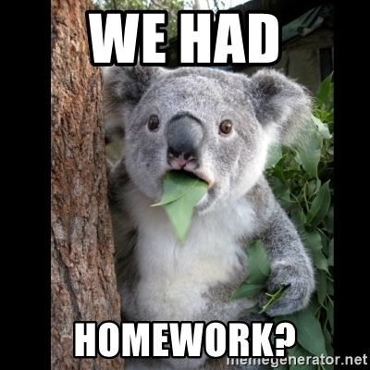

Lab Activities:
- You will perform various lab activities throughout the course.
- A Lab Safety Contract must be signed by both you (the student) and your parent/guardian in order to participate in any labs. Lab rules must be followed correctly and safety equipment worn properly.
- Your behavior in the classroom determines whether you will be allowed to participate in the labs.
- If your behavior in the lab requires that you be removed from the activity, you will receive a zero.

Assessments:
- Assessments will be administered as needed and can cover anywhere from one topic to several units.
  - Assessments can be a combination of multiple choice, matching, fill-in-the-blank, identification, short answer questions, and problems.
  - Make-up assessments will be different from the original assessment given. You have 5 school days to make up a missed assessment. You are able to complete the make-up assessment during Enrichment (preferably) or by scheduling a time after school. After the 5th day, the assessment grade will be a zero. Assessments need to be handed back in a timely manner. It is up to YOU to schedule a time for make-up.
  - All grades earned on assessments are initial grades. You have the opportunity to complete a re-take request for any assessment on which you earned a grade lower than 74%.

Notebook:
- You will be responsible for keeping an organized notebook.
- A 1.5” to 2” 3-ring binder is required. The material in this course is extensive and we DO NOT throw anything away!!!
- Paperwork (notes, assignments, etc.) will be placed in the notebook in order by date. We will create a “Table of Contents” for the notebook. The “Table of Contents” will be located on the Google classroom.
- The notebooks will be graded at the end of each grading period and at the end of the course. (the method of grading will be determined prior to the first check.)
- Notebooks may be “cleaned out” after each grading period. Specific materials will be removed and placed in the students file in a filing cabinet for future studying purposes.
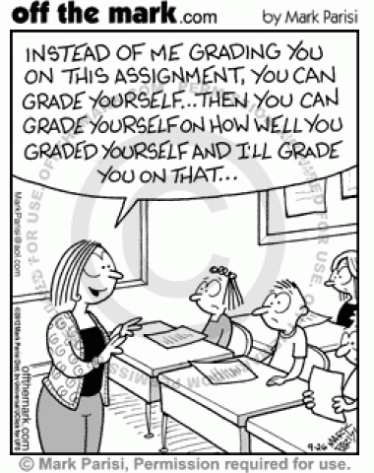

Grading Procedures:

Grading Scale:
- The standard grading scale will be used:
  - A = 93 – 100
  - B = 85 – 92
  - C = 75 – 84
  - D = 70 – 74
  - F = Below 70

Grading System:
- Your total course grade for each nine weeks is based on a total points system using the following categories: (**point values may be adjusted as needed)
  - BioFacts—5 points
  - Homework/Classwork—5-10 points
  - Labs/Projects—15-20 points
  - Quizzes—25 points
  - Tests—100 points
- Your total course grades for Semesters 1 & 2 are divided into the following categories:
  - 40% N1
  - 40% N2
  - 20% Midterm Exam

  - 40% N3
  - 40% N4
  - 20% Final Exam
- **Not all assignments will be graded**
  - Assignments will be checked based on completeness OR correctness. You will NOT be told in advance how the assignment will be graded. It is in your best interest to complete the assignment correctly.
  - If an assignment does not have a date stamp and a grade, check, or sticker, it was never turned in and will be counted as a zero.
  - Your grades and missing assignments can be monitored through the PowerSchool website. If you cannot access PowerSchool, make an appointment with your guidance counselor.

Graded Work
- All graded work will be returned to your personal folder in the bins in the classroom. I do not pass papers back in class as it takes up too much class time. Please get in the habit of checking your folder when you come into class each day.
- You are responsible for putting all work into your notebook (notes, worksheets, graded papers, labs, etc.). You WILL NOT throw anything away.

Tardies, Absences and Make-up Work:

Tardies:
- You are expected to be in the classroom, turning in homework and getting your materials ready when the tardy bell rings. After the bell rings, you should be seated at your desk working on the daily warm-up activity.
- Any student who is not in the classroom when the bell rings will be counted tardy! You will NOT be admitted to class without a permission slip, admit slip, or tardy slip (with legible information completed).
- Tardy discipline policy:
  - 1st tardy = verbal warning
  - 2nd tardy = parent/guardian contact and a behavior notification
  - 3rd tardy = discipline referral
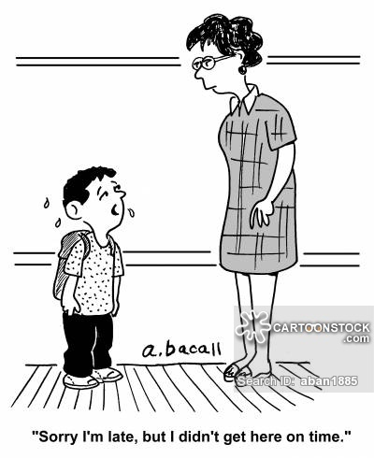

Absences:
- ALL work for absences can and must be made up. Assignments not turned in for grades will be marked as zeroes.
- All work completed/collected while absent will be marked as a zero in PowerSchool until the assignment is made up. **This is a CMCSS District policy**

Make-up Work:
- Attendance in this class is essential. Much of the material necessary for student success is provided through lecture/discussion and group/lab work.
- YOU are responsible for getting your missed assignments and notes AND completing and turning them back in. Upon your return to school, you will pick your make-up work from the Make-Up Work board in the back of the classroom.
- I will NOT remind you that you need to pick up or turn in make-up work. It is YOUR responsibility!
  - So as not to fall behind, you must complete make-up work within the allotted amount of time. You receive one day for each day absent. After the allotted amount of time has passed, late points will be deducted.
  - If you are absent on the day an assignment is due, you should have it ready to turn in on the day you return.
  - If you are absent on the day of an assessment, we will schedule a time during Enrichment for a make-up assessment. We will not make assessments up during class time.
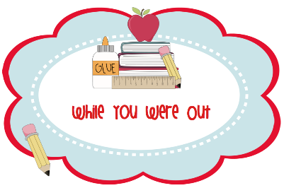
- If you have questions about make-up work or missing assignments, please see me before school, during enrichment, or after school and not during class time.

Extra Credit:
- Extra credit is offered occasionally for various things. It is NOT something that should be expected to help you pass the class.
- I will NOT provide you with a “packet” of make-up work at the end of the grading period in order to bring your grade up.
- Extra credit points are typically not added until the end of the grading period.
- Bonus coupons may be earned for various reasons throughout the school year. These may be used to add points to an assessment grade. I do not keep up with bonus coupons earned. Therefore, they are the responsibility of the student.
- Bathroom passes can also be used for extra credit at the end of each grading period. See the section on this below.

Disciplinary Procedures:
- All students are expected to abide by the Biology class contract and the Student Code of Conduct for Rossview High School and CMCSS.
- Basic class discipline procedure:
  - 1st offense = verbal warning and loss of participation points
  - 2nd offense = contact with parent/guardian, loss of participation points
  - 3rd offense = behavior notification, contact with parent/guardian, loss of participation points
  - 4th offense = discipline referral to the appropriate administrator and loss of participation points
- Some infractions warrant an immediate discipline referral. Cell phones, skipping, and altercations are some examples of these. Please note, if your cell phone is out in class, it will be confiscated and you will receive a discipline referral.

Summary of Class Rules and Expectations:
- Disruptive behavior and talking will not be tolerated. Proper disciplinary action will be taken.
  - Listen when the teacher is talking. Follow directions the first time.
  - Listen when others are talking. Someone may ask something important or have the same question that you have. This class structure relies on good communication.
  - Raise your hand if you would like to talk. Do not interrupt when someone else is talking.
  - Work quietly and do not disturb others.
  - Keep hands, feet, and other objects to yourself.
- Remain seated at all times. Ask permission before leaving your seat. You will be able to throw trash away during clean up time at the end of class. Please sharpen pencils BEFORE class starts.
- No personal grooming in class. This includes hair brushing, make-up application, etc. DO NOT spray perfume/body spray/cologne. People have allergies and asthma and these can trigger reactions.
- No electronic devices or earbuds/headphones are allowed in class. This includes, but is not limited to, cell phones, iPod’s, tablets or other technological devices. This does not include the district-issued computers. We will abide by all school/district policies.
- No cursing/profanity or inappropriate jokes/comments.
- No gum, food, or drink in the classroom or lab area. NO EXCEPTIONS! If you have any food or drink items, they must be placed in the food and drink tray on the shelf by the classroom door and can be picked up when leaving the classroom.
- Students are not permitted in the laboratory or behind my desk without permission.
- Show respect for school property, other students personal property, and my personal property. You will be held responsible for any damages that are caused.

Miscellaneous Information:

Bathroom Privileges:
- You will be given three bathroom passes per quarter. You may choose to use these passes throughout the quarter or may turn them in for extra credit at the end of each quarter.
  - Using the bathroom beyond the emergency passes will be addressed on an individual basis but may result in a loss of points for the day or the accumulation of a tardy.
  - Exceptions can and will be made for students with a medical need.

End of Class:
- The bell does not dismiss you. It is simply a reminder that I need to excuse you from class.
- Stay in your assigned seat until you have been dismissed. You will not crowd in front of the door. This is a school policy! Failure to abide by this rule will result in disciplinary action.
- Make sure your area is neat and clean. Pick up any trash around your desk and place it in the trashcan as you exit the room.

Supplies:
Each student will need to have the following items for class:
- 1.5” to 2” 3-ring binder
- #2 pencils with erasers or BLUE or BLACK pens
- 3x5 index cards
- a highlighter

Classroom Wish List:
Although not included as supplies, our classroom could always use the following:
Amazon Wish List
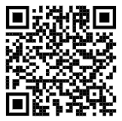
- boxes of tissues
- hand sanitizer (not scented)
- rolls of paper towels
- 12 count boxes of colored pencils
- boxes of nitrile, vinyl, or latex gloves
- https://www.amazon.com/hz/wishlist/ls/1VUKBX43744DP?ref_=wl_share

